October 2014



*The size of the harvest is bigger than you can imagine, but there are few workers*. ~Matthew 9:37 (CEB)

FamilyLife has **Ministry Advisors** who will help find resources and guide you so that you’ll be equipped to minister to your circle of influence. Last year, because of a shortage of Advisors, we were unable to call back 7,000 people who had asked for help to learn how to minister in their churches, neighborhoods and businesses. To meet this need, FamilyLife has moved 14 staff couples into this role and Steve is supervising them. Please pray for this transition and thank God for these outreach opportunities.

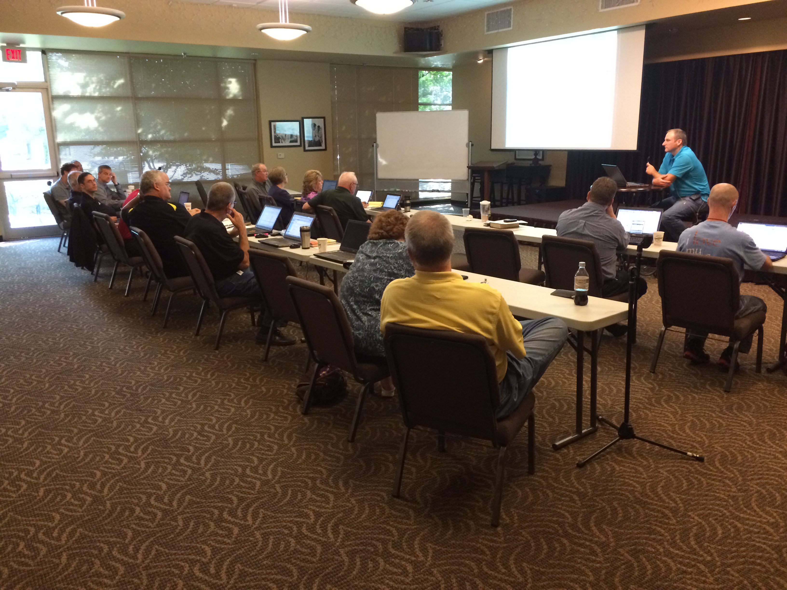 Notables and Prayer

**We will be in Topeka, KS at two events!**

* ***“I Still Do”* FamilyLife Simulcast**

**Saturday Nov. 15th** [**www.istilldo.com**](http://www.istilldo.com)

**8:30am-4:00pm. Topeka Bible Church, Topeka, KS. Call (785) 234-5545 for information and to register.**

*Seating Limited*

* **Steve & Lila Missions Update**

**Sunday, Nov. 16th, 6:30-8:00pm**

**Topeka Bible Church, Topeka, KS**

***We hope to see you at both events!***

*“We recently came through a rough spot. We’re seeing a counselor and those conversations always seem to focus on the negative. The conference focused on the positives and was so encouraging!” ~*Attendee

* Pray for our year-end financial support needs. Each year we depend on one-time, extra or increased support gifts to offset pledges that did not come in. This year we also have additional expenses from Steve’s surgery last month and we will need to raise money for our required bi-annual Cru U.S. Staff Conference at Colorado State University in July with 6,000 missionaries.
* Steve’s surgery went well last month and Lila’s knee is about as well as we can expect.

Thanks so much for playing such a huge part in ministry with us through your prayers and financial support as we minister to people through FamilyLife all over the world.

Serving Him,

Steve and Lila Bayer

FamilyLife Missionary Staff, [www.bayerfamilylife.com](http://www.bayerfamilylife.com)

To support our ministry, [**https://give.cru.org/0634047**](https://give.cru.org/0634047)